**Web Design and Programming (7175 & 6691)**

**Assignment 1**

**Submission**:

* A .zip file that contains all files in your web project. Submit this .zip file on the Canvas site of this unit.
* Two usernames and passwords for admin user and registered user.

**Late submission**: 5% of the total mark (i.e., 1.5 mark) per day. Information on how to apply for extension can be found in the unit outline available on the Canvas site of this unit.

**Topic**: Website for **Industry 4.0** – also known as the fourth industrial revolution – with 6 companies and organisations: IBM, Amazon, Google, Microsoft, CSIRO, and Department of Industry, Science, Energy and Resources, and 6 emerging technologies: Artificial Intelligence (AI), Internet of Things (IoT), Cognitive Computing, Cloud Computing, Robotics, and Blockchains.

**Tasks**: Design and implement a responsive website for **Industry 4.0** using the following:

1. **ASP.NET Core Web App (Model-View-Controller)** template in Visual Studio 2019 or 2022. Language: **C#**.
2. **HTML5, CSS3, Bootstrap** and **media query** for **responsive web design**.
3. **JavaScript** and **jQuery** for interactive **website**.
4. Admin users can add more company or organisation to the page for emerging technologies.
5. Registered users can post feedback but only admin users can edit or delete current posts.

**Requirements**:

1. **Website**:
   * Full-width layout and responsive design for all web pages.
   * 4 public pages including home page, a page for 6 companies and organisations, a page for 6 emerging technologies, and a page for contact and about. Links to those pages are available on the main menu.
   * 5 private pages (Create, Details, Delete, Edit and Index) for registered users and admin users to create, post, edit and delete feedback. Users who are not logged in cannot see and access to these pages.
2. **Home page:** to introduce Industry 4.0, the 6 emerging technologies, and 6 web sites about Industry 4.0. Use **parallax scrolling** and **bootstrap carousel sliding** techniques. Details are shown below.
3. **Page for companies and organisations:** to introduce 6 companies and organisations which are IBM, Amazon, Google, Microsoft, CSIRO, and Department of Industry, Science, Energy and Resources. Details are shown below.
4. **Page for emerging technologies:** to introduce the 6 core technologies: Artificial Intelligence (AI), Internet of Things (IoT), Cognitive Services, Cloud Computing, Robotics, and Blockchains. ~~Use~~ *~~jQuery elastic grid~~* ~~to~~ list 24 web sites in square blocks related to the 6 technologies. These 24 square blocks are grouped into 6 groups of 4. Details are shown below.
5. **Page for contact, about and other useful information:** to present contact details, information about this website, copyright, and other useful information on Industry 4.0. Details are shown below.
6. **Five private pages (Create, Details, Delete, Edit and Index)** for registered users and admin users to create, post, edit and delete feedback. These 5 web pages must be generated by MVC Entity Framework. The list of all feedback posts in Index page is also listed on the public page for 6 companies and organisations. Users who are not logged in cannot see and access to these pages.
7. Handle all exceptions that may occur at runtime (– 1 mark for each exception found). Make sure your web site provides the same display on the following web browsers: Google Chrome and MS Edge (– 2 marks if not the same).

**Details**

**The design must be the same as you see on the screenshots below.**

1. **Website**: **Full-width layout** (left and right margin < 15px) and **responsive design** for all 5 public web pages. Links to those 5 web pages are available on the main menu.

* Example of full-width layout website: <https://www.ibm.com/services/artificial-intelligence>
* Example of boxed-design layout website (not full-width layout and not used in this assignment): <https://www.headland.com.au/industry-4-0-cheat-sheet-industry4-0-cloud-computing-smart-factory-internet-of-things/>
* Example of responsive website: <https://www.microsoft.com/en-us/ai/default.aspx>
* Example of non-responsive website (not used for this assignment): <https://dequeuniversity.com/library/responsive/1-non-responsive>

1. **Home page:** to introduce Industry 4.0, the 6 emerging technologies, and 6 web sites about Industry 4.0. Use **parallax scrolling** and **bootstrap carousel sliding** techniques. Below are the layouts required for this page on different devices.

**Laptop and desktop**

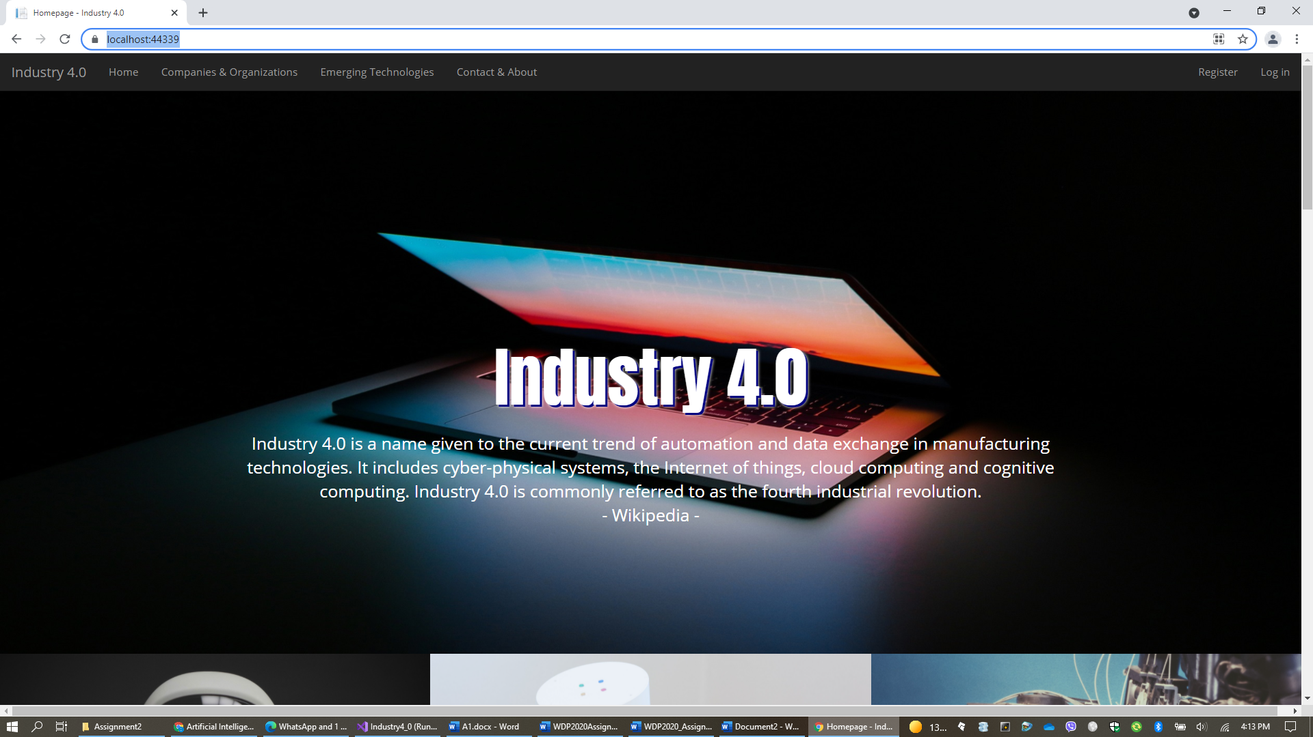

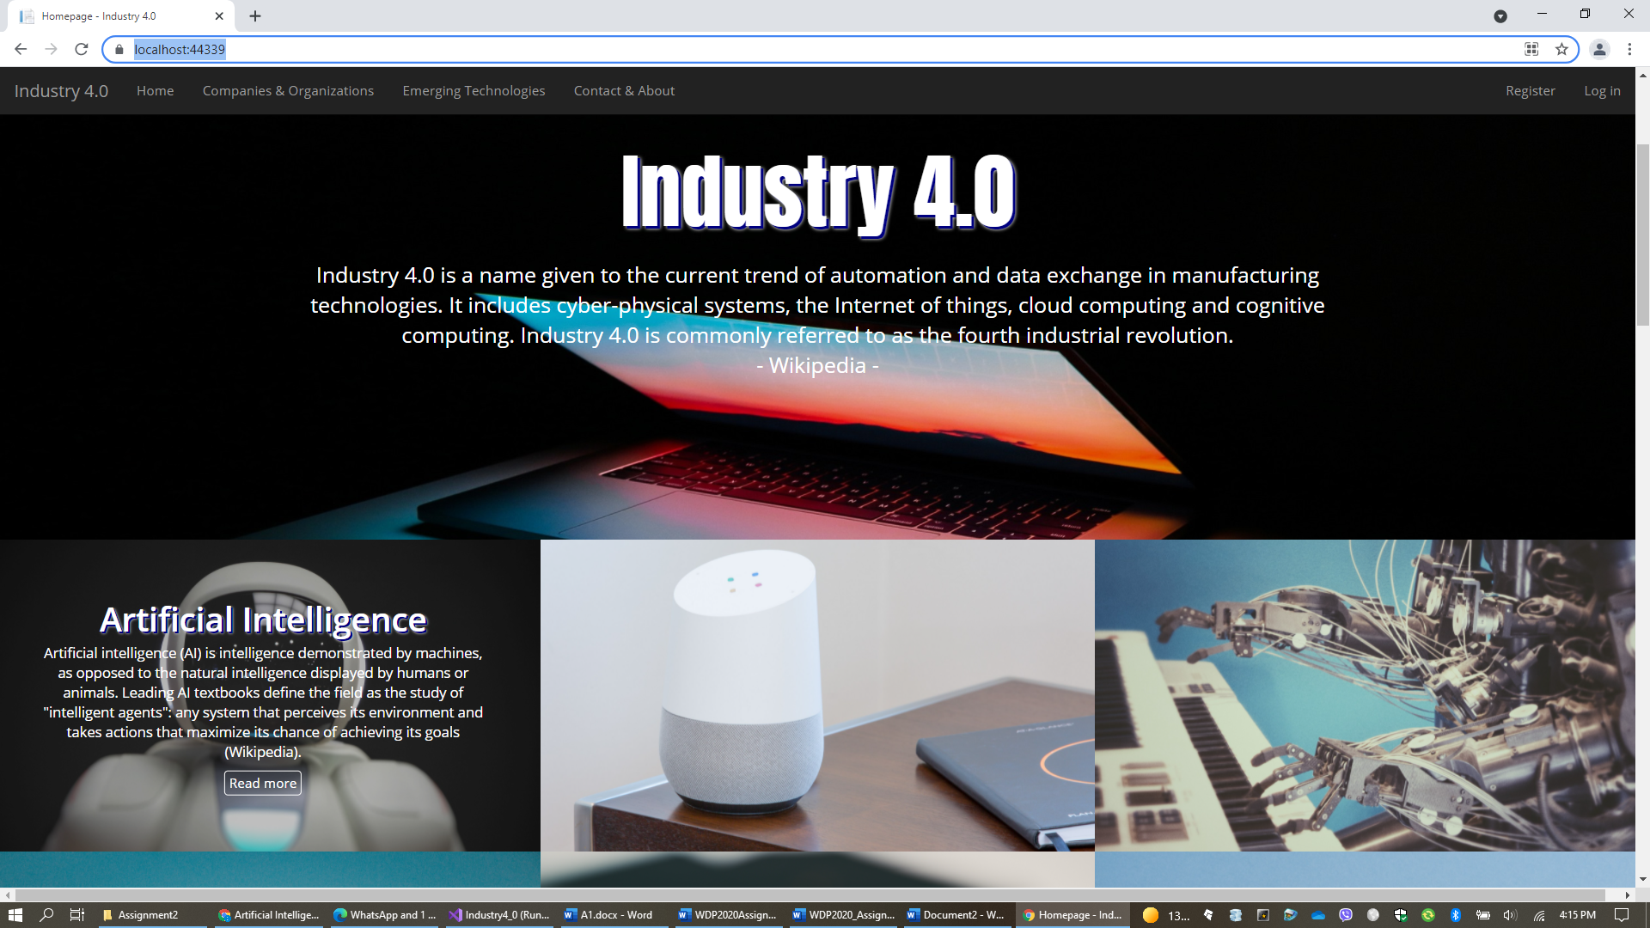

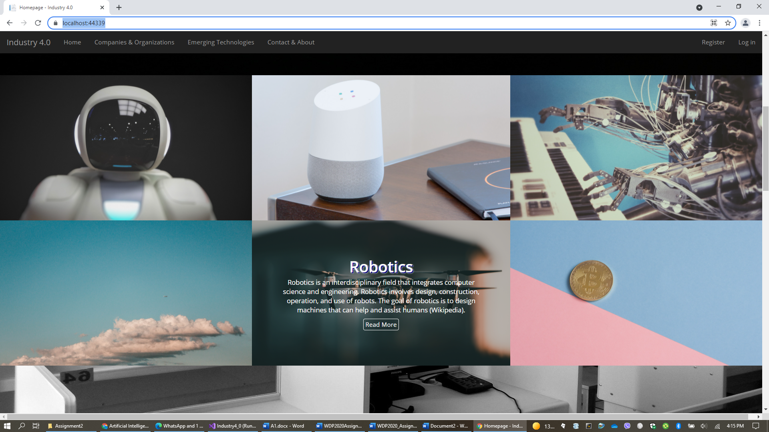

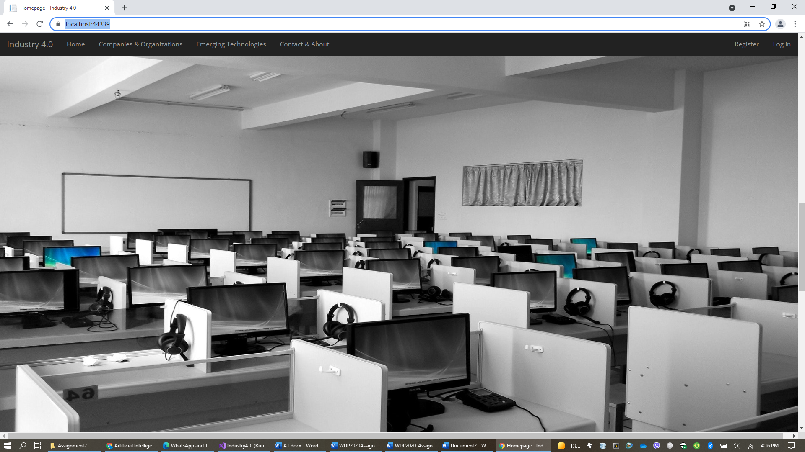

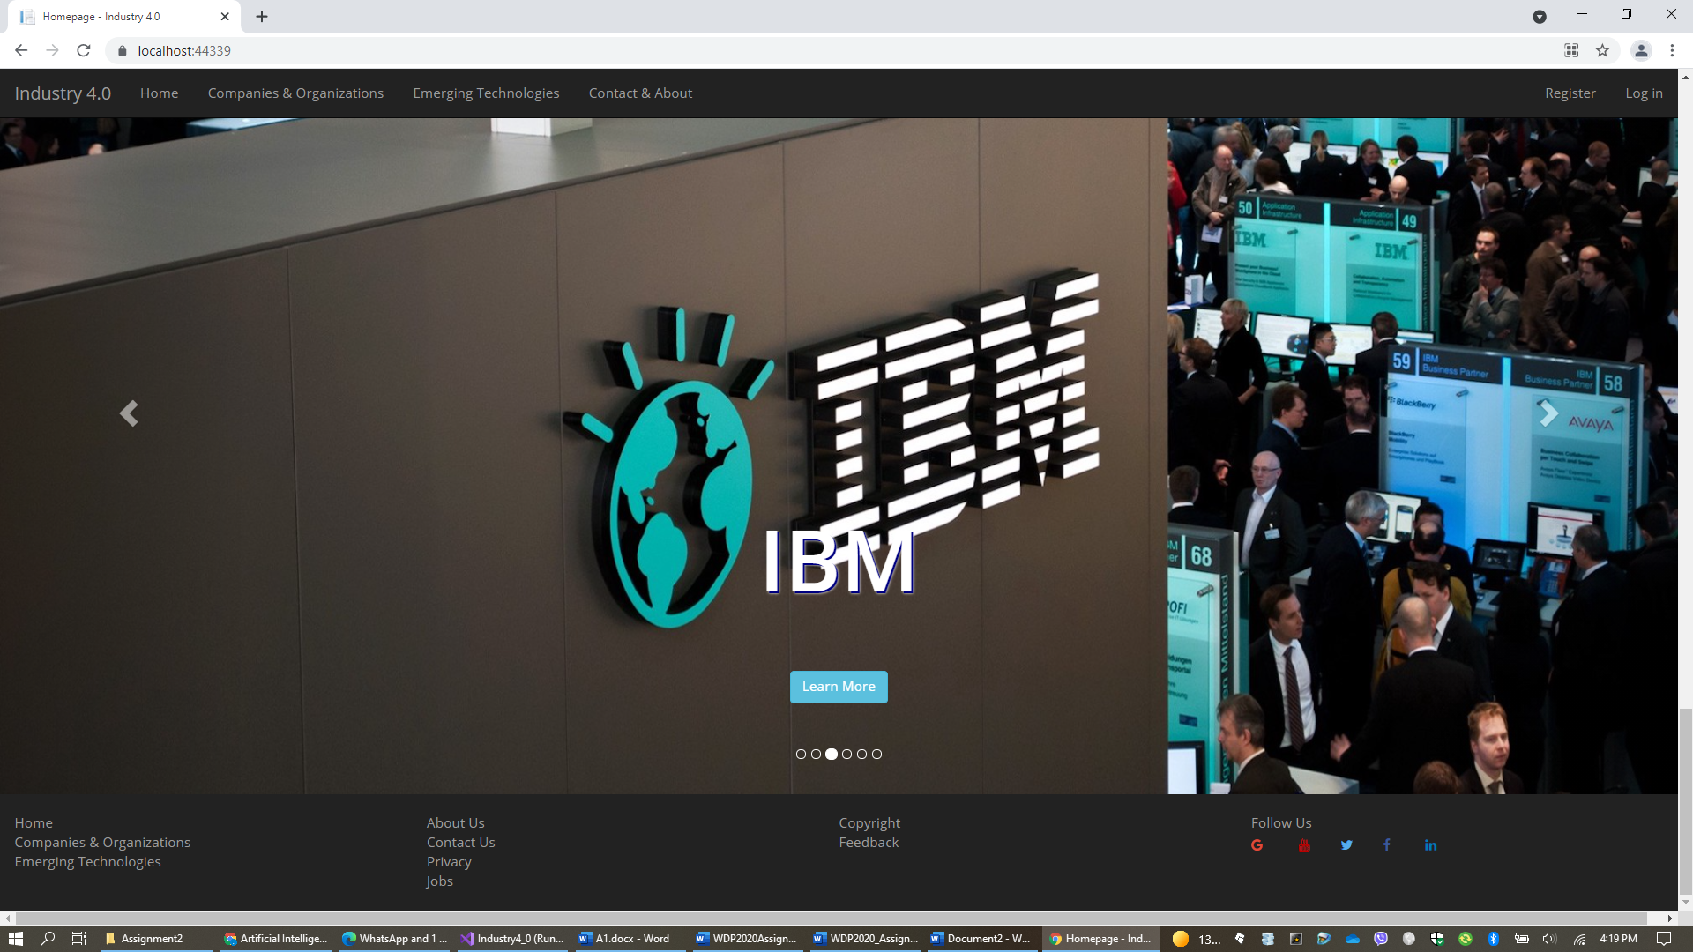

**Tablet**

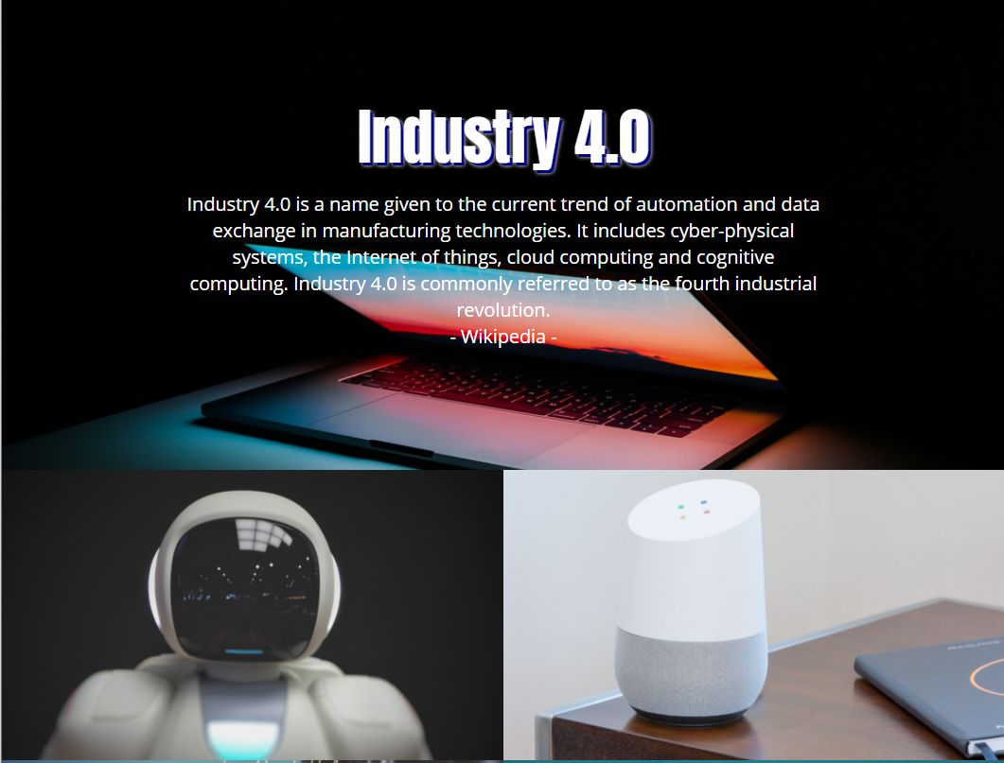

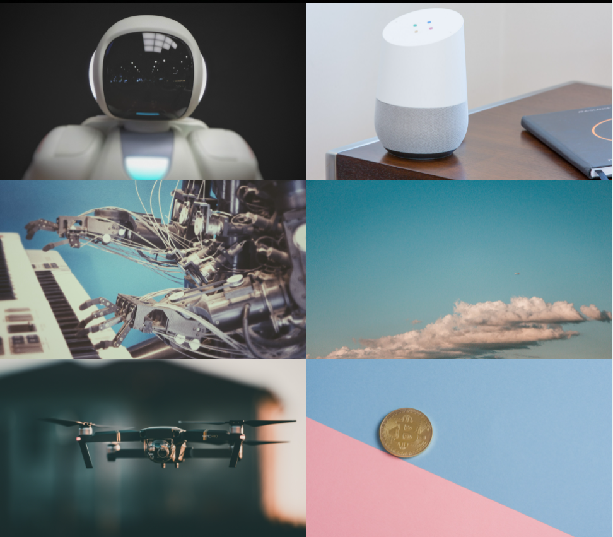

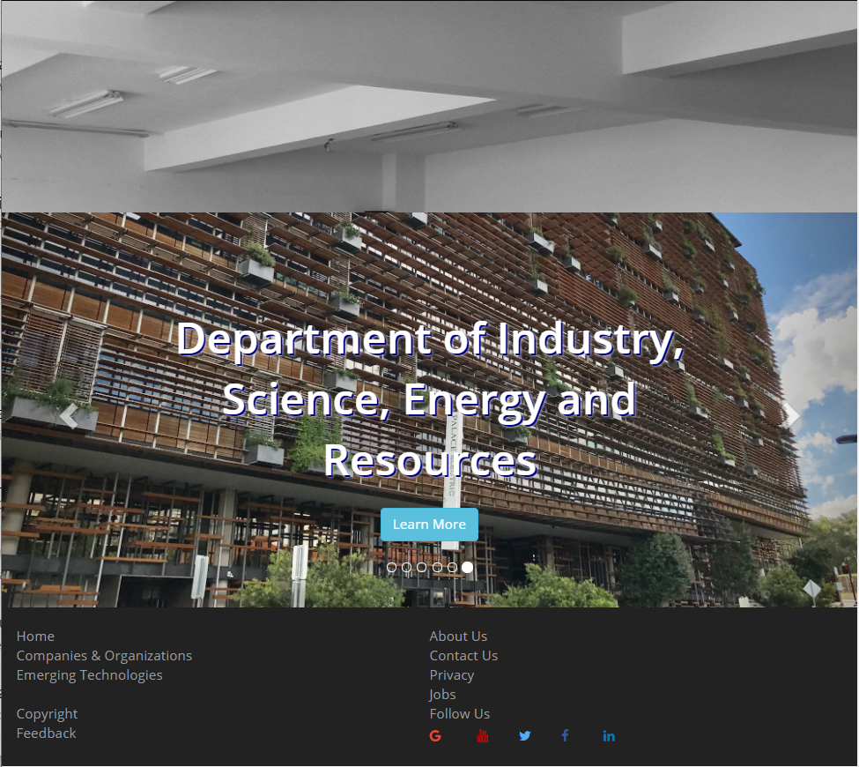

**Mobile Phone**

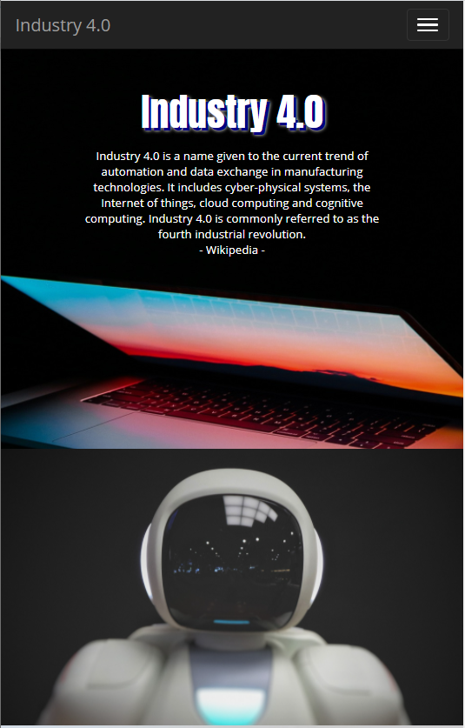

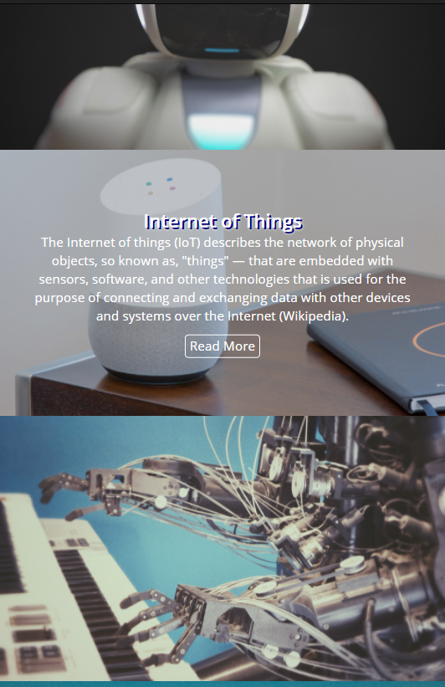

 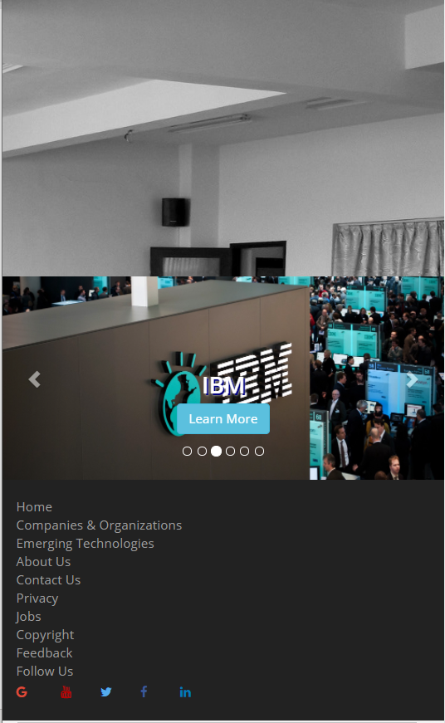

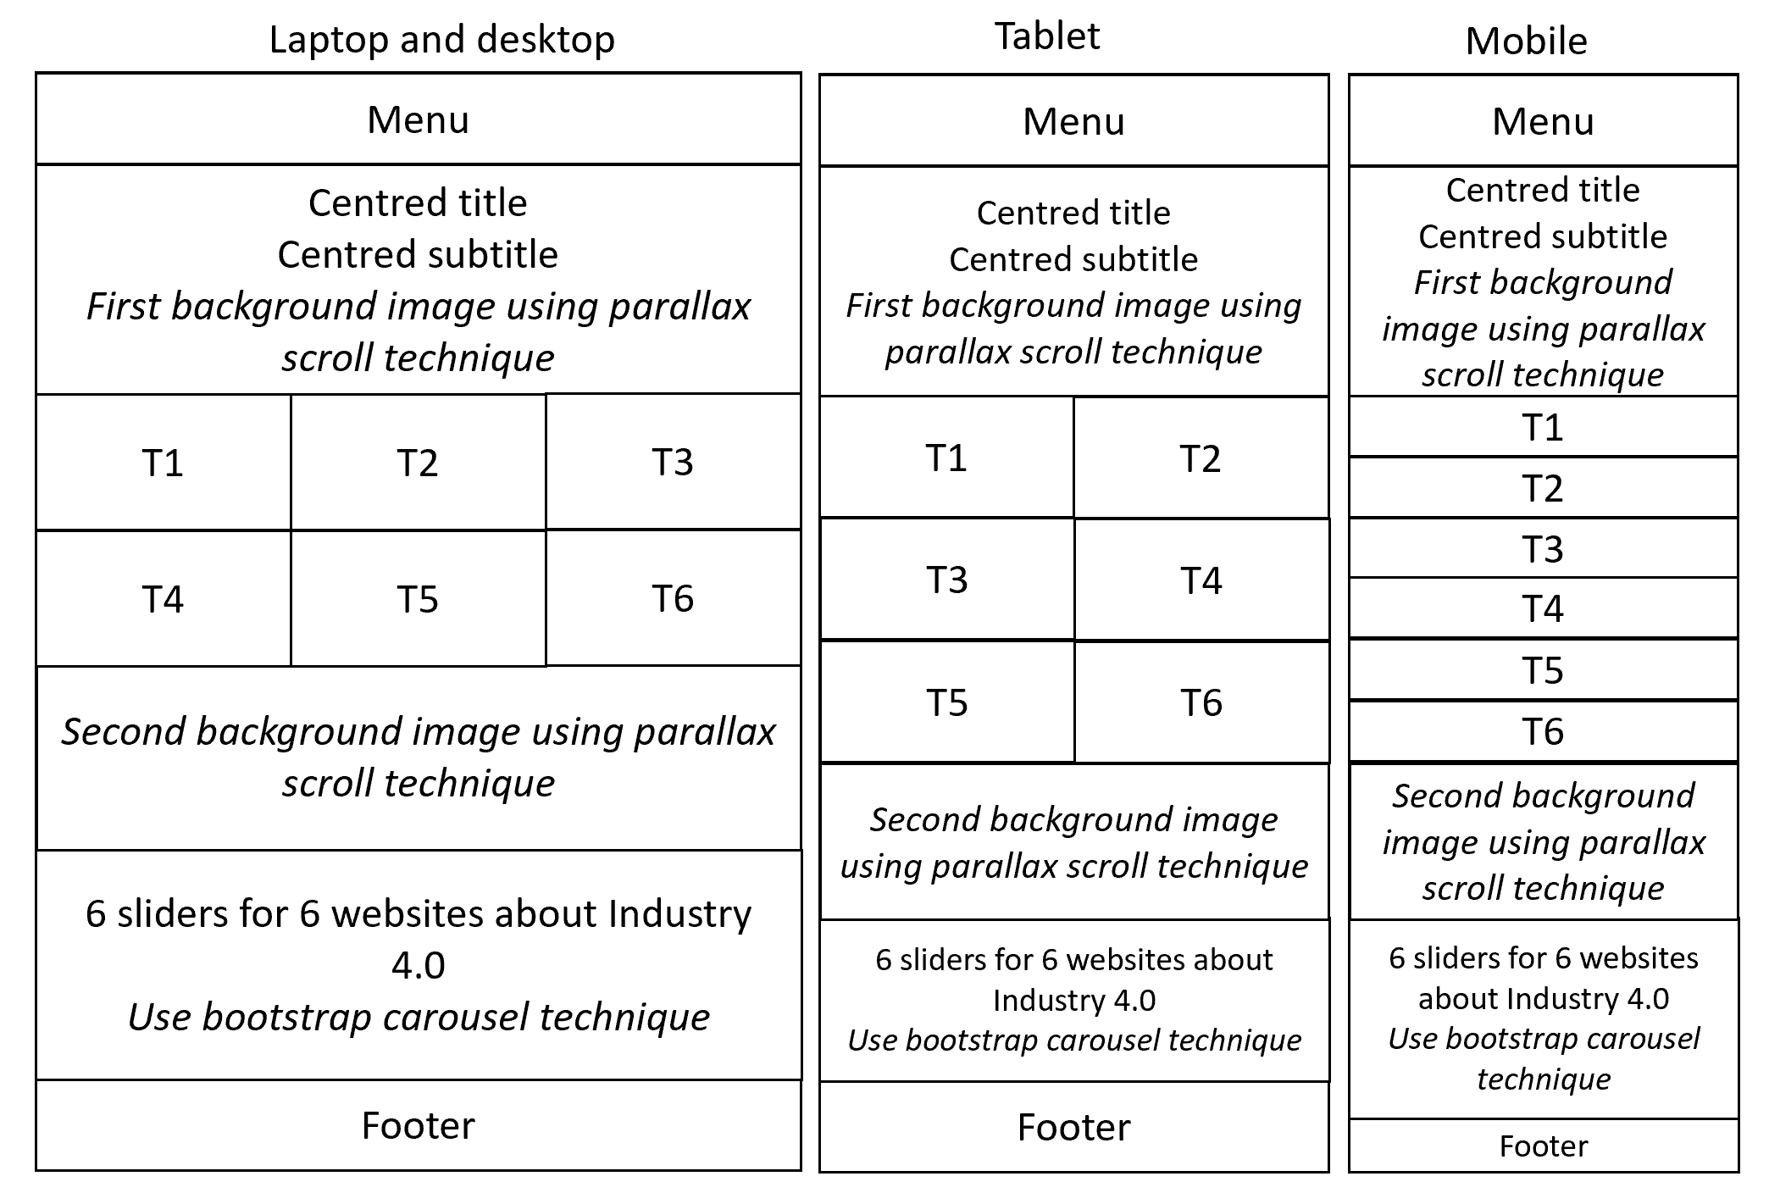

* T1, T2, …, T6 are for 6 emerging technologies: Artificial Intelligence (AI), Internet of Things (IoT), Cognitive Services, Cloud Computing, Robotics, and Blockchains.
* Each of these T1, T2, …, T6 blocks is designed as a rectangular block. No space between these blocks as seen in the above screenshots.
* When the user moves the mouse over on a block (e.g., Artificial Intelligence), the information for this block appears. If the user clicks READ MORE on this block, the website will navigate to the corresponding block on **Emerging Technologies** page (i.e., the Artificial Intelligence block on this page). For example,

 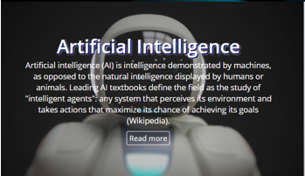

*mouse over*

* Example of parallax scrolling technique and bootstrap carousel sliding technique are introduced in lectures and tutorials.
* For 6 slides on the carousel slider, if the user clicks LEARN MORE on a slide, the user will be redirected to the official website introduced on that slide. Right-click to copy the hyperlinks for these 6 websites: [IBM](https://www.ibm.com/industries/manufacturing?S_PKG=ov60479&cm_mmc=Search_Google-_-Industrial_Industrial+-+Discrete+Manufacturing-_-WW_NA-_-industry+4.0_Exact_ov60479&cm_mmca1=000020DR&cm_mmca2=10005255&cm_mmca7=9071954&cm_mmca8=kwd-297031802574&cm_mmca9=9a244c0e-4e2f-4a0c-879b-abaf5cee4a64&cm_mmca10=280798821827&cm_mmca11=e&mkwid=9a244c0e-4e2f-4a0c-879b-abaf5cee4a64|1082|36760&cvosrc=ppc.google.industry%204.0&cvo_campaign=000020DR&cvo_crid=280798821827&Matchtype=e), [Amazon](https://aws.amazon.com/ai/), [Google](https://ai.google/), [Microsoft](https://www.microsoft.com/en-us/ai?activetab=pivot1%3aprimaryr6), [CSIRO](https://www.csiro.au/), and [Department of Industry, Science](https://www.industry.gov.au/), Energy and Resources.
* **Texts to include to this home page**
  + Industry 4.0: Industry 4.0 is a name given to the current trend of automation and data exchange in manufacturing technologies. It includes cyber-physical systems, the Internet of things, cloud computing and cognitive computing. Industry 4.0 is commonly referred to as the fourth industrial revolution. Wikipedia
  + Block T1: Artificial intelligence (AI) is intelligence demonstrated by machines, as opposed to the natural intelligence displayed by humans or animals. Leading AI textbooks define the field as the study of "intelligent agents": any system that perceives its environment and takes actions that maximize its chance of achieving its goals (Wikipedia).
  + Block T2: The Internet of things (IoT) describes the network of physical objects, so known as, "things" — that are embedded with sensors, software, and other technologies that is used for the purpose of connecting and exchanging data with other devices and systems over the Internet (Wikipedia).
  + Block T3: Cognitive computing (CC) refers to technology platforms that, broadly speaking, are based on the scientific disciplines of artificial intelligence and signal processing. These platforms encompass machine learning, reasoning, natural language processing, speech recognition and vision (object recognition), human–computer interaction, dialog and narrative generation, among other technologies (Wikipedia).
  + Block T4: Cloud computing is the on-demand availability of computer system resources, especially data storage (cloud storage) and computing power, without direct active management by the user. Large clouds often have functions distributed over multiple locations, each location being a data center (Wikipedia).
  + Block T5: Robotics is an interdisciplinary field that integrates computer science and engineering. Robotics involves design, construction, operation, and use of robots. The goal of robotics is to design machines that can help and assist humans (Wikipedia).
  + Block T6: A blockchain is a growing list of records, called blocks, that are linked together using cryptography. Each block contains a cryptographic hash of the previous block, a timestamp, and transaction data (generally represented as a Merkle tree) (Wikipedia).
* **Images for this home page**: download on Canvas site of this unit.

1. **Page for companies and organisations:** to introduce 6 companies and organisations which are IBM, Amazon, Google, Microsoft, CSIRO, and Department of Industry, Science, Energy and Science. Below are the layouts required for this page on different devices.

**Laptop and desktop**

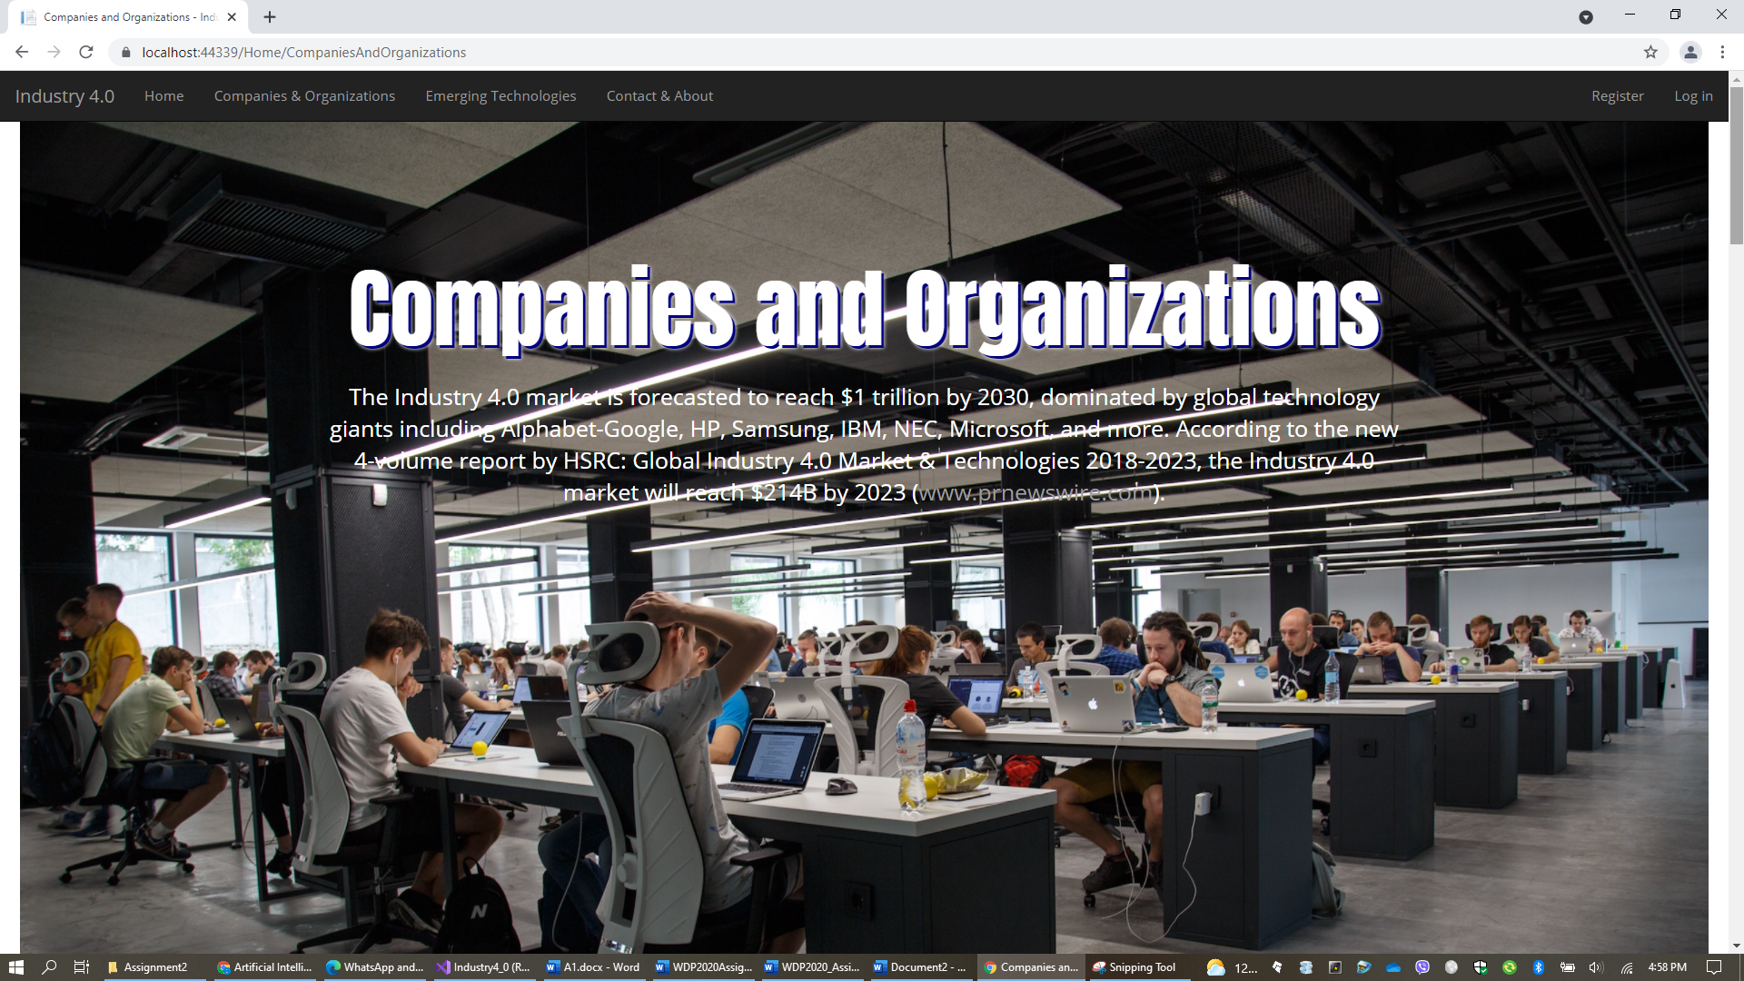

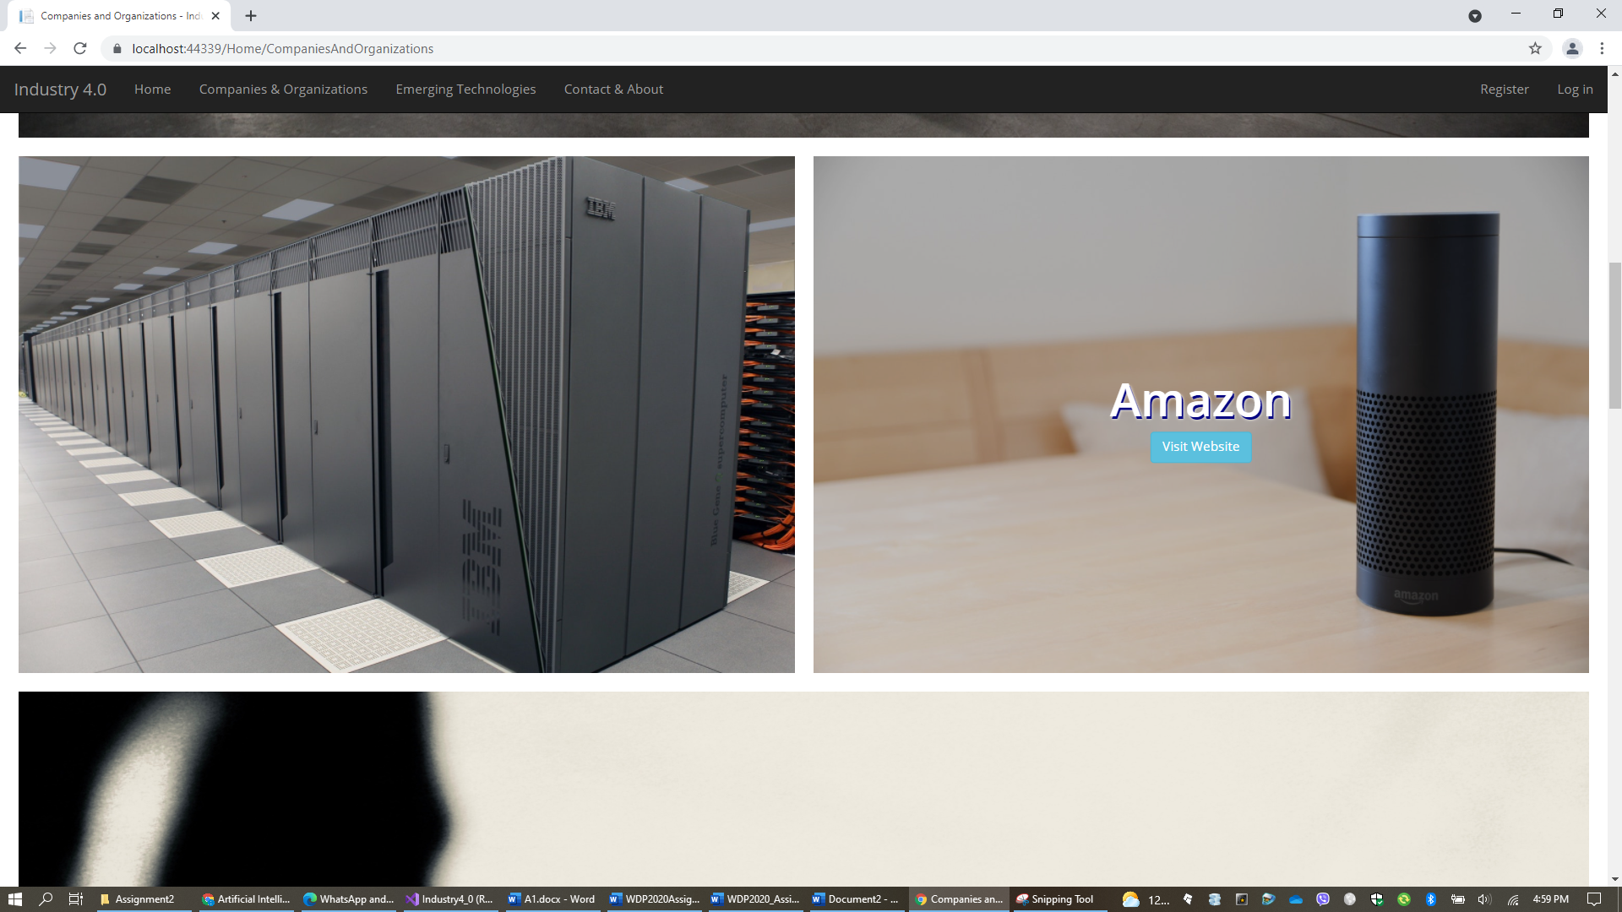

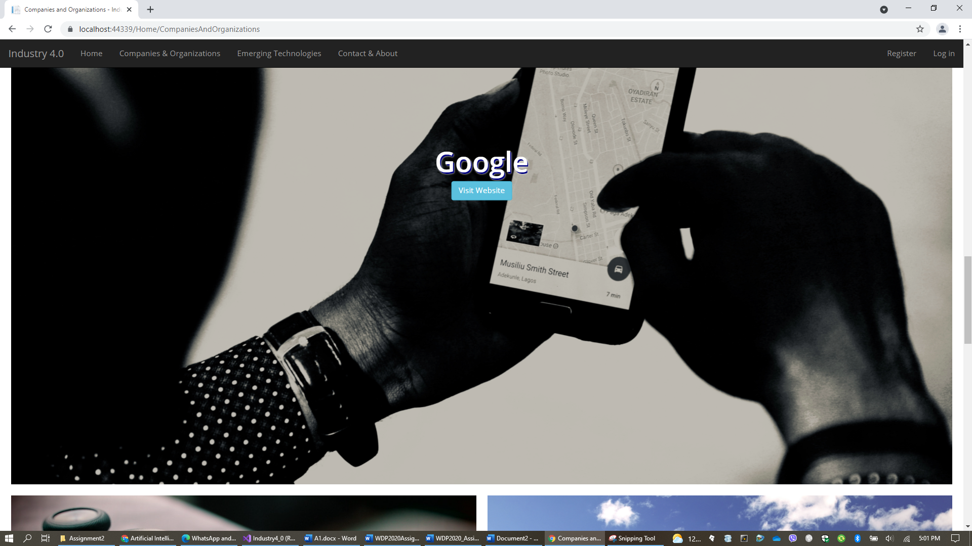



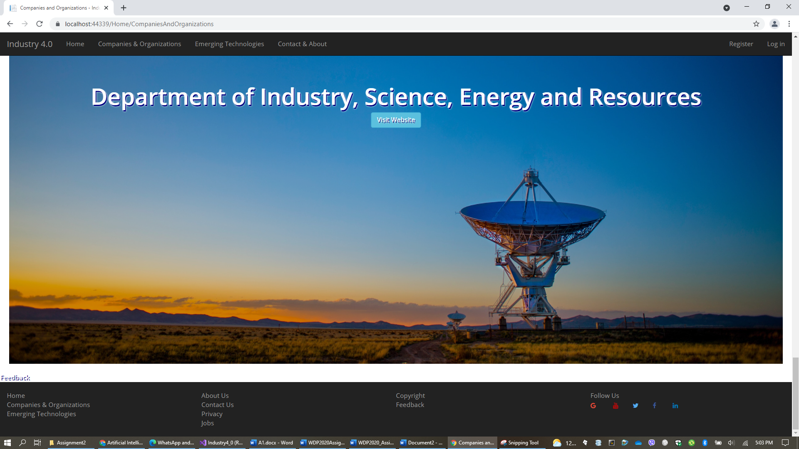

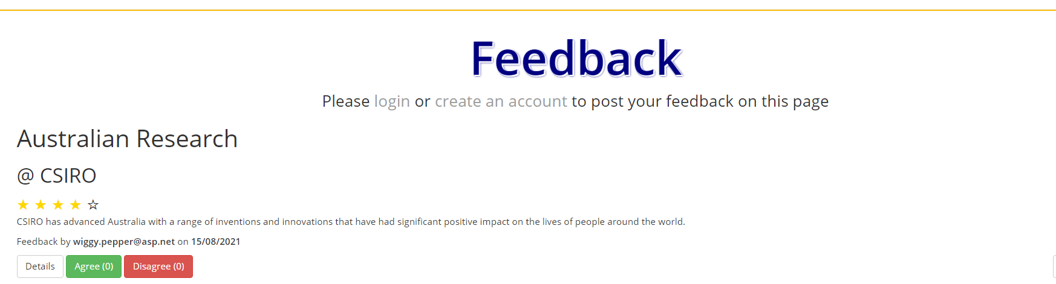

**Tablet**

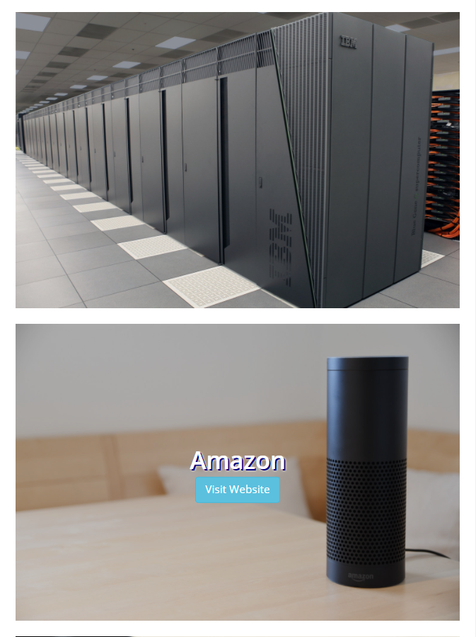 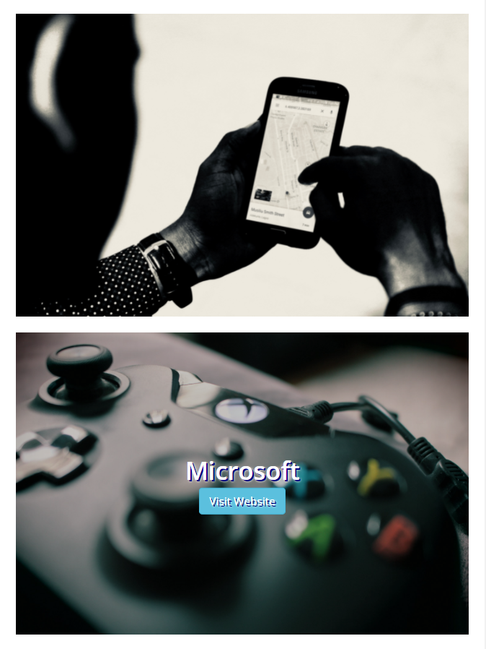

 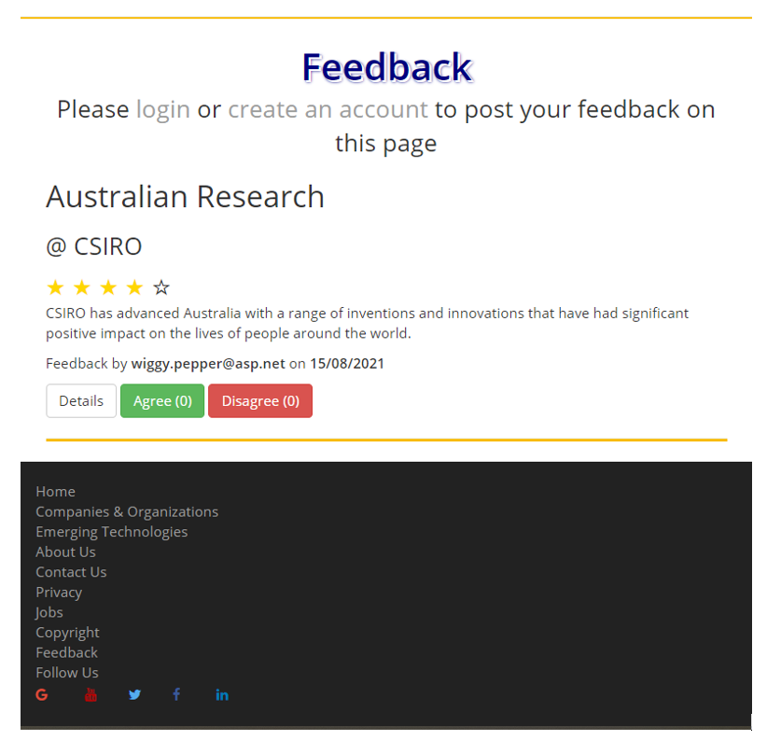

**Mobile Phone**

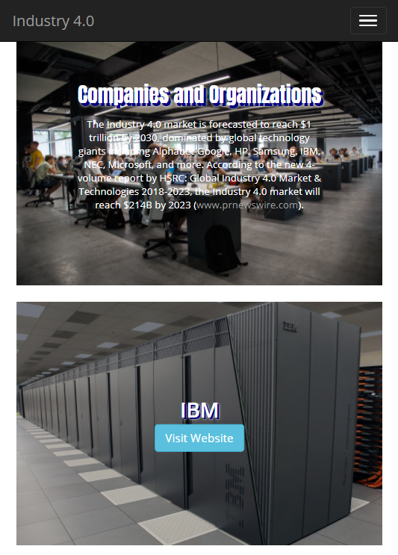 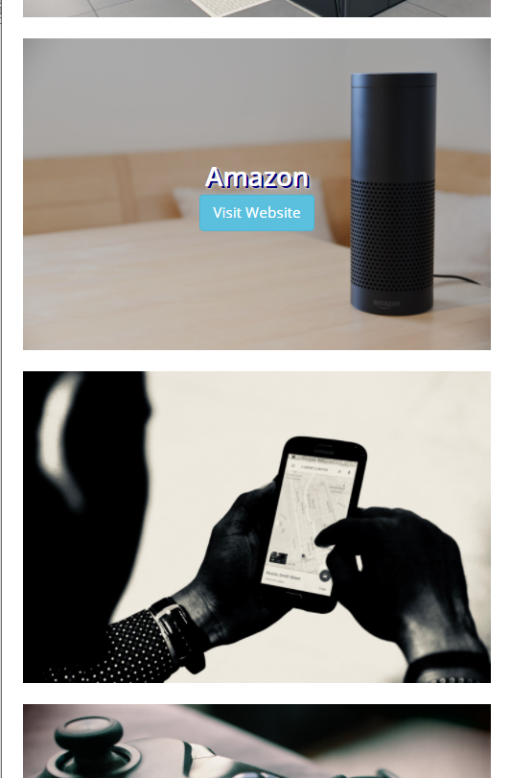

 

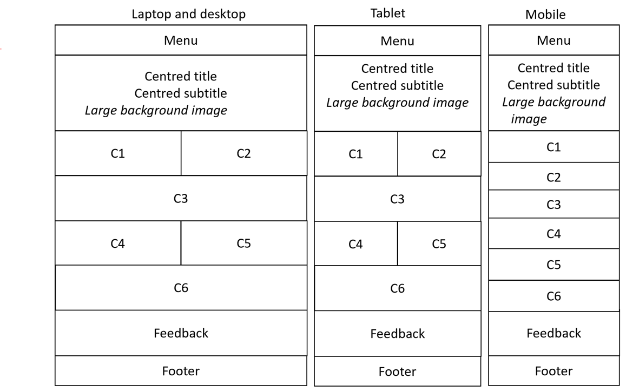

* C1, C2, …, C6 are for 6 companies and organisations: IBM, Amazon, Google, Microsoft, CSIRO, and Department of Industry, Science, Energy and Resources.
* When the user moves the mouse over on each block C1, C2, …, or C6, the name of that company or organisation and a button **Visit Website** appear. If the user clicks this button, the user will be redirected to the official website of that company or organisation.
* Right-click to copy the hyperlinks for these 6 websites: [IBM](https://www.ibm.com/industries/manufacturing?S_PKG=ov60479&cm_mmc=Search_Google-_-Industrial_Industrial+-+Discrete+Manufacturing-_-WW_NA-_-industry+4.0_Exact_ov60479&cm_mmca1=000020DR&cm_mmca2=10005255&cm_mmca7=9071954&cm_mmca8=kwd-297031802574&cm_mmca9=9a244c0e-4e2f-4a0c-879b-abaf5cee4a64&cm_mmca10=280798821827&cm_mmca11=e&mkwid=9a244c0e-4e2f-4a0c-879b-abaf5cee4a64|1082|36760&cvosrc=ppc.google.industry%204.0&cvo_campaign=000020DR&cvo_crid=280798821827&Matchtype=e), [Amazon](https://aws.amazon.com/ai/), [Google](https://ai.google/), [Microsoft](https://www.microsoft.com/en-us/ai?activetab=pivot1%3aprimaryr6), [CSIRO](https://www.csiro.au/), and [Department of Industry, Science](https://www.industry.gov.au/), Energy and Resources.
* **Text to include to this web page**: The Industry 4.0 market is forecasted to reach $1 trillion by 2030, dominated by global technology giants including Alphabet-Google, HP, Samsung, IBM, NEC, Microsoft, and more. According to the new 4-volume report by HSRC: Global Industry 4.0 Market & Technologies 2018-2023, the Industry 4.0 market will reach $214B by 2023 (https://www.prnewswire.com/news-releases/global-tech-giants-to-lead-the-industry-40-revolution-300585640.html)
* **Images for this page**: download on Canvas site of this unit.

1. **Page for emerging technologies:** you will apply **your own design** to this web page to introduce the 6 core technologies: **Artificial Intelligence (AI)**, **Internet of Things (IoT)**, **Cognitive Computing**, **Cloud Computing**, **Robotics** and **Blockchain**, and **at least 12 companies** (2 for each of the 6 core technologies) from the list of 24 companies below.
   * This web page must have **responsive design** and **at least one design technique** such as *accordion*, *modal boxes, collapsible, scroll drawing*, or *jQuery elastic grid*.
   * The 24 companies grouped into 6 groups of 4 are as follows (click to have a look)
   * **AI**: [IBM](https://www.ibm.com/watson/) AI, [Microsoft](https://www.microsoft.com/en-us/ai/default.aspx) AI, [CSIRO](https://data61.csiro.au/en/Our-Work/AI-and-Machine-Learning) AI, [Amazon](https://aws.amazon.com/machine-learning/ai-lex-polly-rekognition/) AI
   * **IoT**: [IBM](https://www.ibm.com/blogs/internet-of-things/industry-4-0/) IoT, [Microsoft](https://www.microsoft.com/en-au/internet-of-things/) IoT, [Amazon](https://aws.amazon.com/iot/?sc_channel=PS&sc_campaign=acquisition_AU&sc_publisher=google&sc_medium=iot_nb&sc_content=iot_e&sc_detail=iot&sc_category=iot&sc_segment=154387165862&sc_matchtype=e&sc_country=AU&s_kwcid=AL!4422!3!154387165862!e!!g!!iot&ef_id=WmksLwAAAHVHXlHa:20180805102347:s) IoT, [CIO](https://www.cio.com.au/article/641518/feds-launch-ai-iot-projects/) IoT
   * **Cognitive Computing**: [IBM](https://www.ibm.com/services/artificial-intelligence) CC, [Microsoft](https://azure.microsoft.com/en-au/services/cognitive-services/) CC, [Google](https://cloud.google.com/vision/) CC, [Forbes](https://www.forbes.com/sites/bernardmarr/2016/03/23/what-everyone-should-know-about-cognitive-computing/#62c3c5885088) CC,
   * **Cloud Computing**: [Google](https://cloud.google.com/solutions/iot/) Cloud, [Microsoft](https://azure.microsoft.com/en-au/) Cloud, [IBM](https://www.ibm.com/cloud/) Cloud, [Amazon](https://aws.amazon.com/) Cloud
   * **Robotics**: [Forbes](https://www.forbes.com/sites/jimlawton/2018/03/20/the-role-of-robots-in-industry-4-0/#69de1dca706b), [ZDNet](https://www.zdnet.com/article/robotics-and-industry-4-0/), [I-Scoop robots cobots](https://www.i-scoop.eu/robots-cobots-logistics-4-0/), [Automation World](https://www.automationworld.com/industry-40-here-are-you-ready)
   * **Blockchain**: [Blockchain](https://www.blockchain.com/), [PC Magazine](https://au.pcmag.com/amazon-web-services/46389/feature/blockchain-the-invisible-technology-thats-changing-the-world), [Forbes](https://www.forbes.com/sites/andrewrossow/2018/04/11/bringing-blockchain-into-industry-4-0/) Blockchains, [CSIRO](https://www.data61.csiro.au/en/our-work/safety-and-security/secure-systems-and-platforms/blockchain) Blockchains

* Footer: use the same footer with the other web pages.

1. **Page for contact, about and other useful information:** you will apply **your own design** to this web page to present contact details, information about this website, copyright, and other useful information on Industry 4.0. Below are the layouts required for this page on different devices.

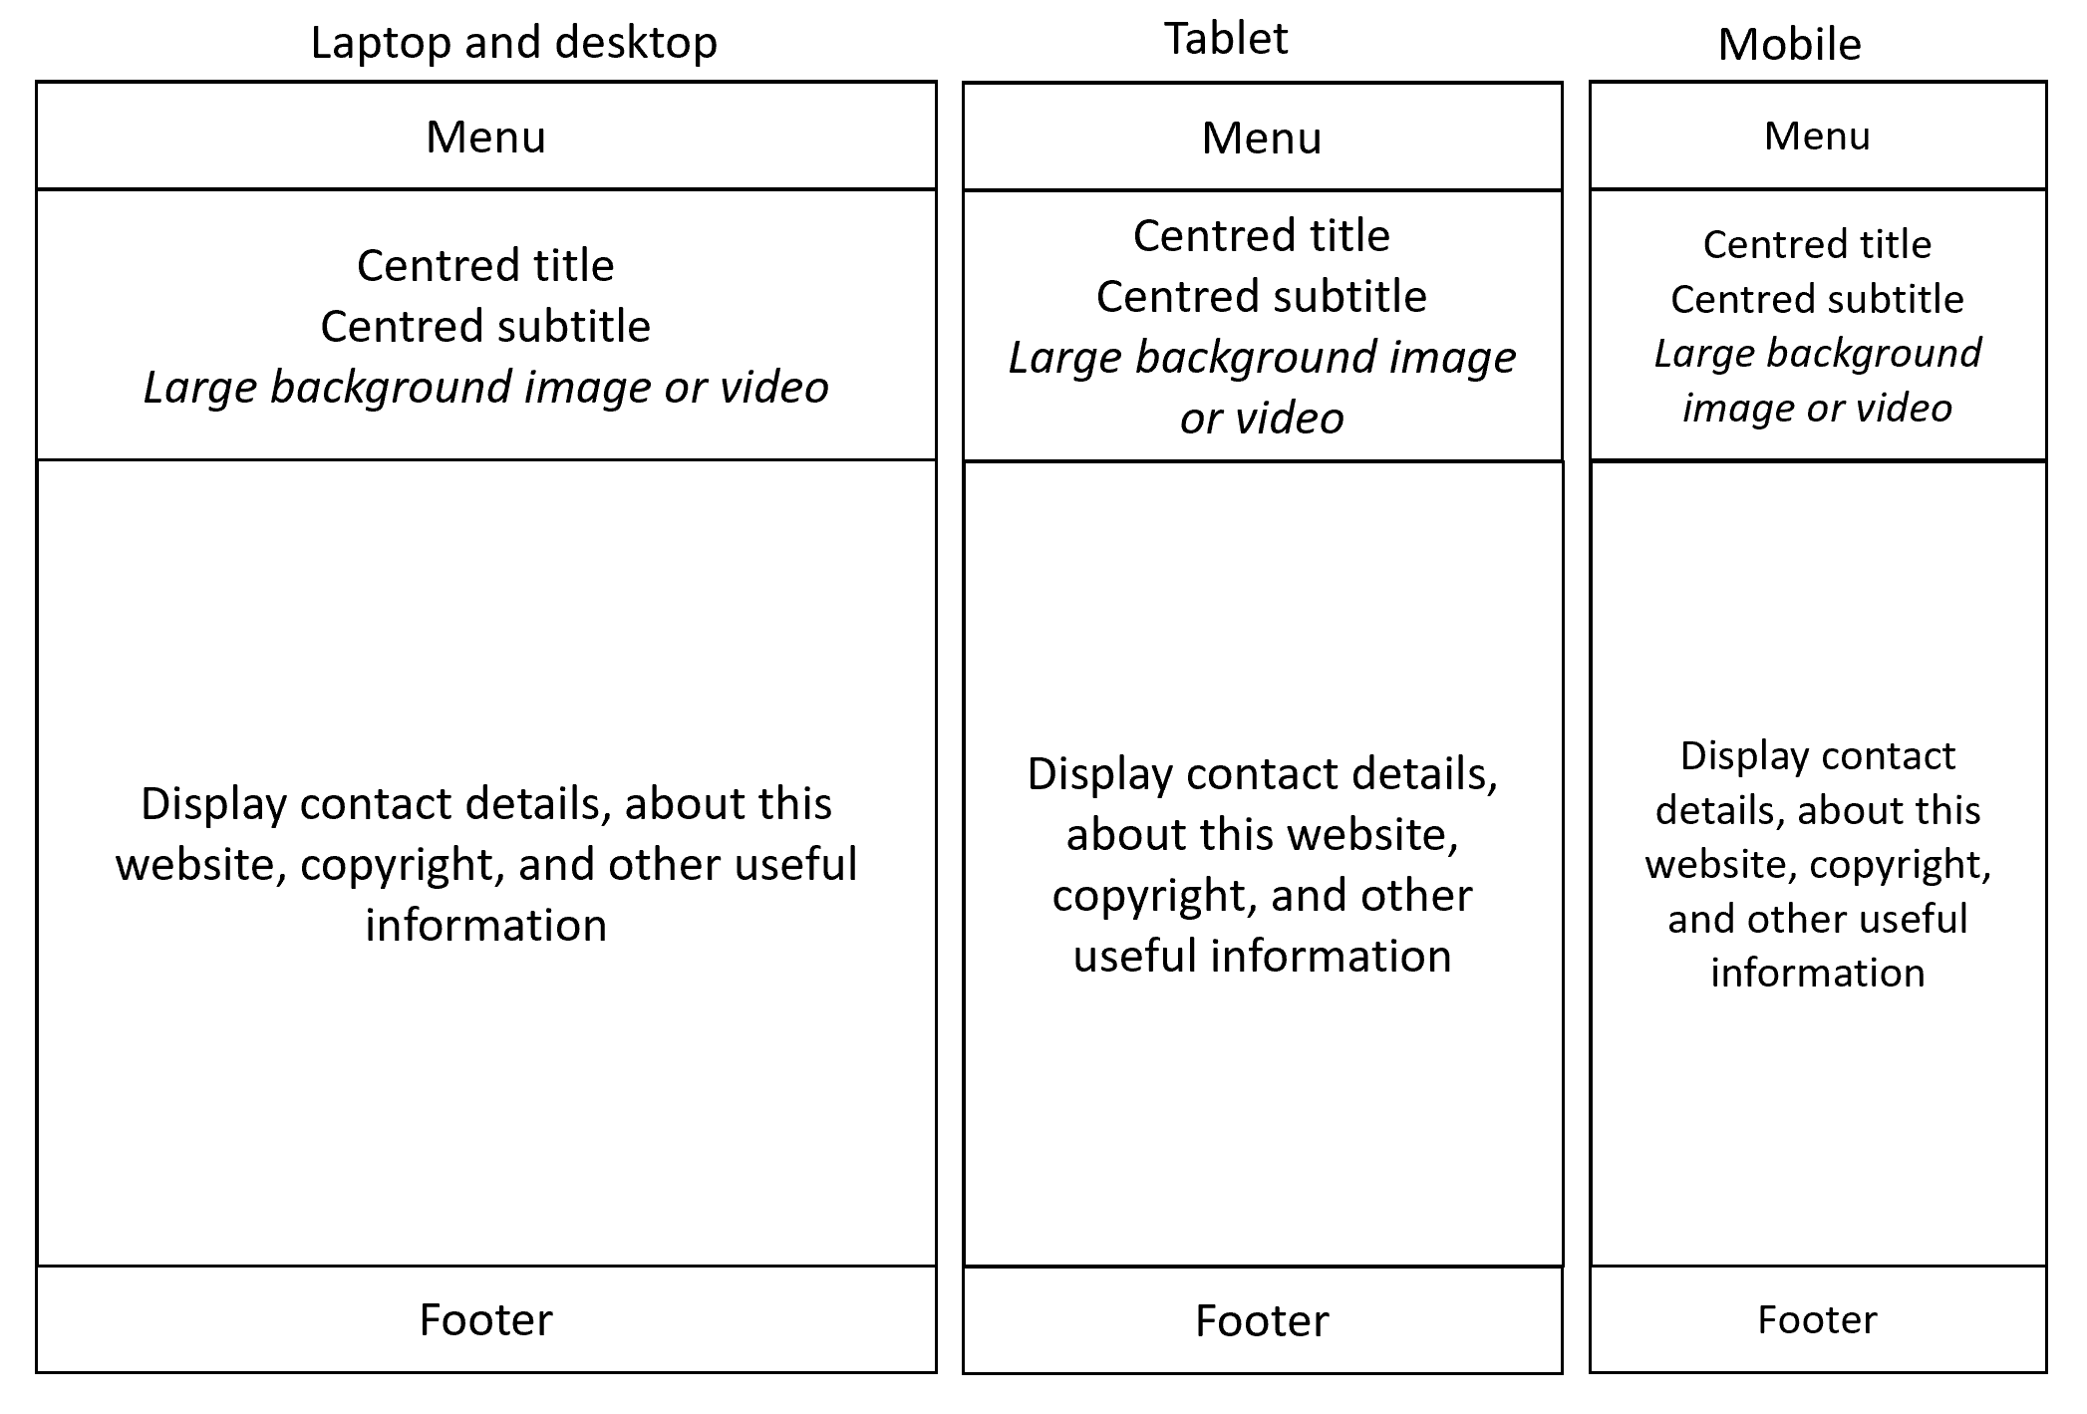

* Example of contact and about pages: <http://www.ibm.com/ibm/us/en/?lnk=fab>

1. **Five private pages (Create, Details, Delete, Edit and Index)** for registered users and admin users to create, post, edit and delete feedback. These 5 web pages must be generated by MVC Entity Framework. The list of all feedback posts in Index page is also listed on the public page for 6 companies and organisations. Users who are not logged in cannot see and access to these pages.

* The list of feedback posts is **sorted by date**, from newest to oldest.
* If the user clicks **Register** on the main menu, the following page will appear for the user to register.

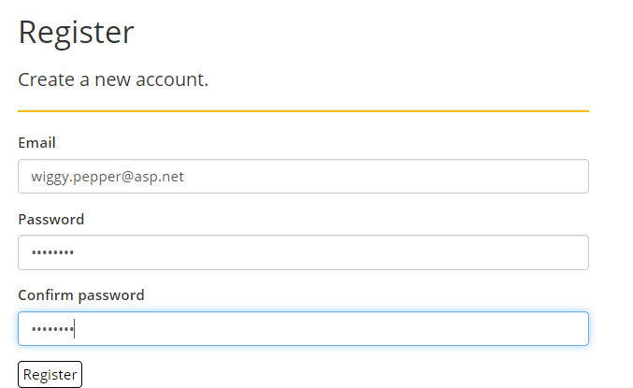

* If the user clicks **Log in** on the main menu, the following page will appear for the user to log in.

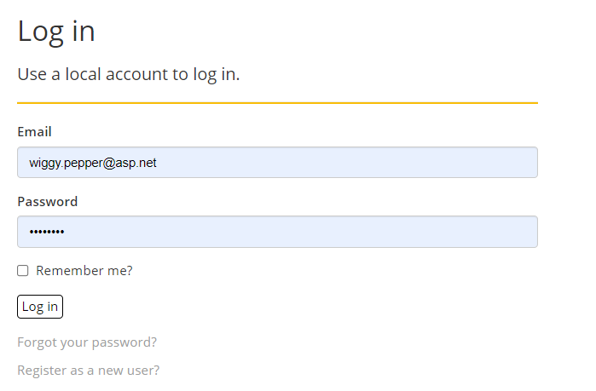

* After the user is logged in (either admin or registered user), the user will be redirected back to the **page for companies and organisations** and the following line



is replaced with the blue button **Submit your feedback** below (other content and layout on this page remain the same)



* If the user clicks on this **Submit your feedback** button, the user will see the **Create your feedback** page below. Your page design is required to be the same as this design.

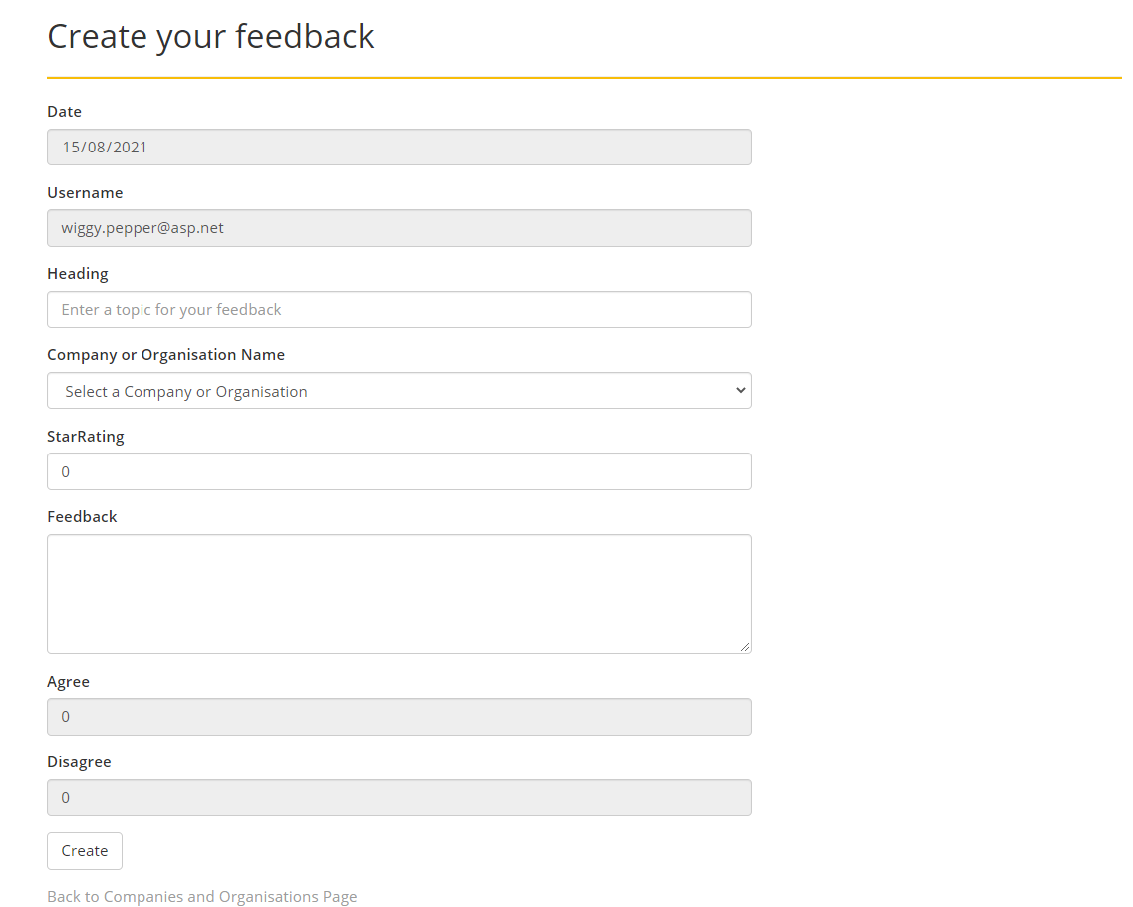

* 1. **Date**: the current date (when the user opens this page) and disabled.
  2. **Username**: the username (for login) and disabled.
  3. **Company or Organisation Name**: a dropdown list for 6 names Amazon, CSIRO, Google, IBM, Microsoft, Department of Industry, Science, Energy and Resources.
  4. **Rating**: the numbers for rating will be 0, 1, 2, 3, 4 and 5 (your website needs to handle exceptions if the user does not enter a number between 0 and 5)
  5. **Feedback**: the input text box can display at least 5 lines.
  6. **Agree** and **Disagree**: current value is 0 and disabled.
* The user will use this page to create a new feedback post as follows: the user enters a heading, selects a company name, changes the star rating, and enters feedback. After the user clicks the **Create** button, the user will be redirected back to the **page for companies and organisations** and will see the new feedback post added to the **top** of the feedback list. The number entered for star rating will be the number of yellow stars seen on the post.
* If the user is **admin**, after logged in the user will see two extra buttons (**Edit** and **Delete**) appeared on every feedback post as seen below. However, if the user is not admin (i.e. just a **registered user**), the user will not see these two buttons. Note your page design is required to be the same as this design.

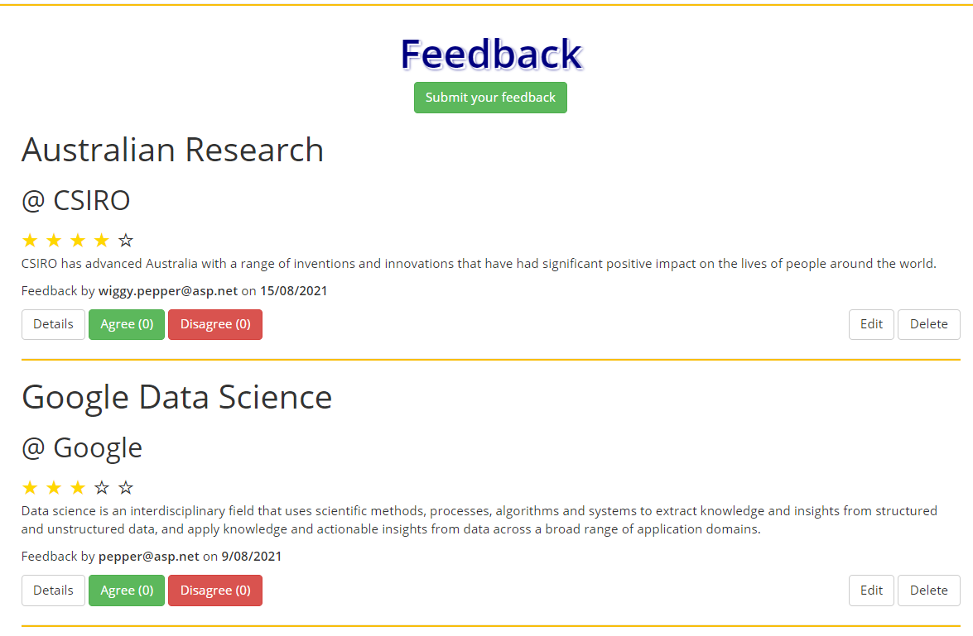

* If the **admin** clicks on the **Edit** button, the admin will see the **Edit** page below. The admin edits all details except the date and username (greyed out, not editable) then clicks the **Save** button. The admin will then be redirected back to the **page for companies and organisations**. The admin will see the updated feedback post on this page. **Note: the date appeared on this Edit page is the current date at which the Edit form is opened.** Your page design is required to be the same as this design.

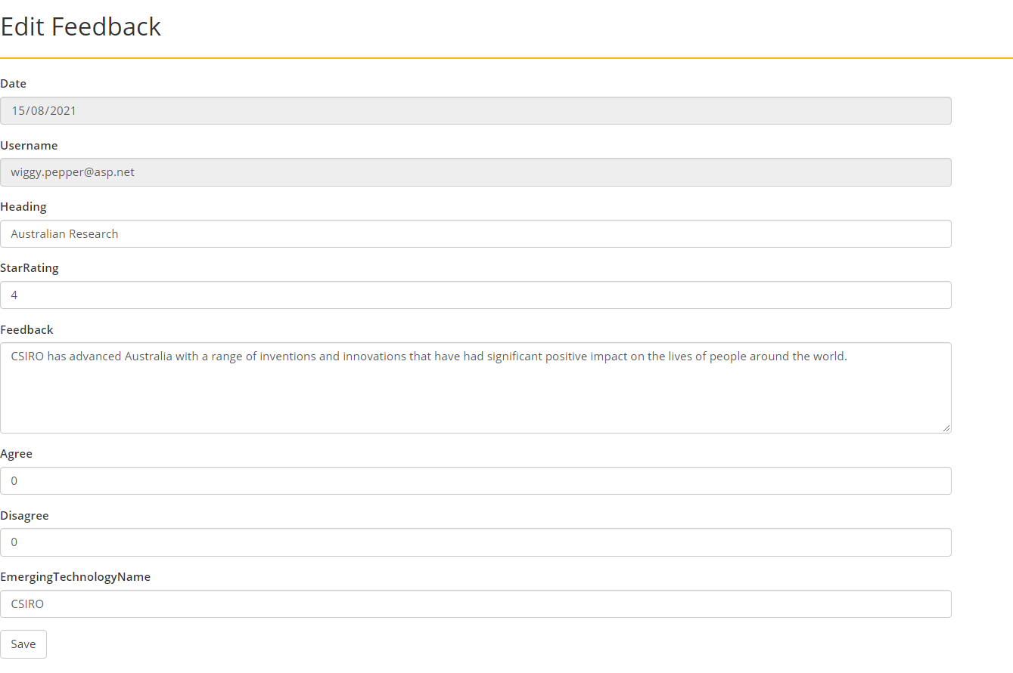

* If the admin clicks on the **Delete** button of a review, the **Delete** page will appear as seen below with all details of that review. Your page design is required to be the same as this design.

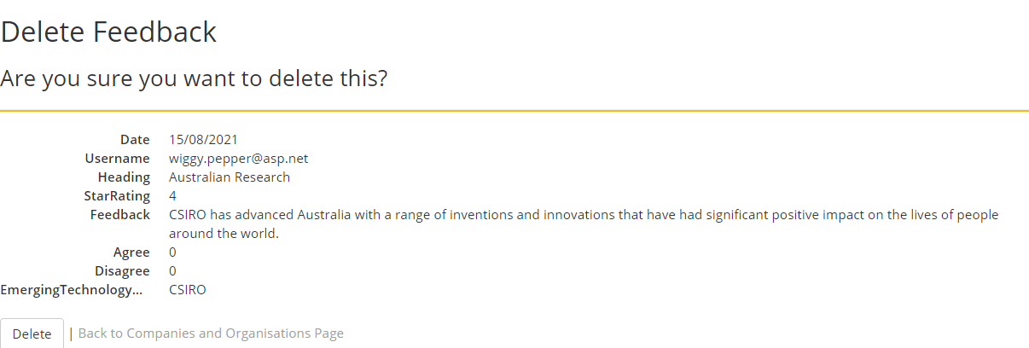

After clicking the **Delete** button, the admin will be redirected back to the **page for companies and organisations** and will not see that feedback post as it has been removed from the list. If the admin clicks on **Back to Companies and Organisations Page**, the admin will be redirected back to the **page for companies and organisations.**

* If the logged user (admin or registered) clicks on **Agree**, it will add 1 to the next number (for example **Agree (11)** becomes **Agree (12)** after clicked). There is no change if the user clicks again. However, if the registered user wants to increase this number one more time, the user needs to logoff then login.
* If the logged user (admin or registered) clicks on **Disagree**, it will add 1 to the next number (for example **Disagree (4)** becomes **Disagree (5)** after clicked). There is no change if the user clicks again. However, if the user wants to increase this number one more time, the user needs to **logoff then login**.
* If the logged user (admin or registered) clicks on **Details** (for example on the first post), the page below will appear. Note your page design is required to be the same as this design.

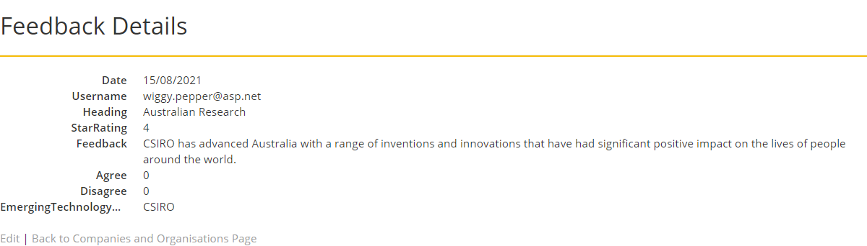

If the logged user clicks on **Edit**, the user will be redirected to the **Edit** page. If the user clicks on **Back to Companies and Organisations Page**, the user will be redirected back to the **page for companies and organisations.**